**Module Description**

Medicine is the study of diseases and medical conditions; risk factors, causes, management and complications to the human body while integrating knowledge from other related disciplines in the understanding of disease processes.

Unit One; STIs/HIV-AIDS

**TOPIC 1.1: What is an STI?**

The term "sexually transmitted diseases" is used to denote disorders spread principally by intimate sexual contact.

There are other diseases that can be spread via sexual contact and other means e.g brucellosis, ebola etc. These diseases are however not classified as STI as sexual contact is not their primary mode of transmission.

Although sex usually means sexual intercourse, it also includes;

1. Close body contact,
2. Kissing,
3. Cunnilingus,
4. Anilingus,
5. Fellatio,
6. Mouth–breast contact, and
7. Anal intercourse.

Many sexually transmitted diseases (STDs) can also be acquired by;Transplacental spread, during;

1. Passage through the birth canal, and
2. Via lactation during the neonatal period.

**Role of Clinicians in STI management;**

1. To understand the microbiology of STDs in order to appropriately diagnose and treat patients.
2. To alleviate the symptoms and prevent future sequelae.
3. To prevent the transmission to others including health care professionals.
4. Patient education and counseling.

Prevention through lifestyle and behavioral modification is the primary weapon against the spread of STDs.

Multiple cohort studies have demonstrated the protective effects of both male and female condoms.

**Common causes of STIs.**

The list of organisms traditionally thought of as causing STDs has been extended to include;

1. Cytomegalovirus,
2. Herpes simplex virus type 1 (HSV-1) and type 2 (HSV-2),
3. Chlamydia,
4. Group B Streptococcus,
5. Molluscum contagiosum virus,
6. Sarcoptes scabiei,
7. Hepatitis viruses, and
8. Human immunodeficiency virus (HIV).
9. Some diseases spread by body contact but not necessarily by coitus—eg, pediculosis pubis and molluscum contagiosum.

**Risk factors for STI;**

1. UTI especially by STI pathogens.
2. Female gender.
3. Multiple unprotected sexual contacts.
4. Sex worker.
5. Intravenous drug users.
6. New relationship in the last 2 months.

**General Signs and symptoms of STI;**

Ay patient who present with the following symptoms should be investigated for possible STI.

1. Sores or bumps on the genitals or in the oral or rectal area
2. Painful or burning urination
3. Discharge from the penis
4. Unusual or odd-smelling vaginal discharge
5. Unusual vaginal bleeding
6. Pain during sex
7. Sore, swollen lymph nodes, particularly in the groin but sometimes more widespread
8. Lower abdominal pain in females.
9. Fever
10. Rash over the trunk, hands or feet.

**Specimens for investigating STIs;**

1. Blood;  Whole blood. Serum.
2. Urine.
3. Vaginal swab; High vaginal swab, Low vaginal swab.
4. Rectal swab.
5. Throat swab.
6. Urethral/vaginal secretions.
7. Histological specimen

**1.2: CLASSIFICATION AND GENERAL FEATURES OF STIS.**

**CLASSIFICATION OF STDS;**

1.     Aetiological Classification;

1)    Bacterial

*i.*Chancroid -*Haemophilus ducreyi.*

ii.    Chlamydia -*Chlamydia trachomatis*

iii.    Gonorrhea -*Neisseria gonorrhoeae.*

*iv.*Granuloma inguinale or -*Klebsiella granulomatis.*

*v.*Syphilis -*Treponema pallidum*

2)   Fungal

            i.    Candidiasis (yeast infection)

3)   Viral.

           i.    Viral hepatitis (Hepatitis B virus)—saliva, venereal fluids.

(Note: Hepatitis A and Hepatitis E are transmitted via the fecal-oral route; Hepatitis C is rarely sexually transmittable, and the route of transmission of Hepatitis D (only if infected with B) is uncertain, but may include sexual transmission.

         ii.    Herpes simplex (Herpes simplex virus 1, 2) skin and mucosal, transmissible with or without visible blisters

        iii.    HIV (Human Immunodeficiency Virus)—venereal fluids, semen, breast milk, blood

        iv.    HPV (Human Papillomavirus)—skin and mucosal contact. 'High risk' types of HPV cause almost all cervical cancers, as well as some anal, penile, and vulvar cancer. Some other types of HPV cause genital warts.

         v.    Molluscum contagiosum (molluscum contagiosum virus MCV)—close contact

4)   Parasites.

           i.    Crab louse, colloquially known as "crabs" or "pubic lice" (Pthirus pubis). The infestation and accompanying inflammation is Pediculosis pubis

        ii.    Scabies (Sarcoptes scabiei)

          iii.    Trichomoniasis (Trichomonas vaginalis), colloquially known as "trich"

**2.   Clinical classification.**

1)    Ulcer forming/Genital Ulcer Disease (GUD).

                                         i.    Herpes simples.

                                        ii.    Syphilis/Chancre.

                                       iii.    Chancroid.

                                       iv.    Condylomata acuminate/venereal warts.

                                        v.    Granuloma Inguinale/Donovanosis.

                                       vi.    Lymphogranuloma venereum LGV.

**General features of GUD (Genital Ulcer Disease);**

An ulcer on the genitalia;

1. Glans penis or penile shaft.
2. Labia majora or minora.
3. Vaginal ulcer.

The ulcer is painful in haemophilus ducreyi, herpes genitalis.

Painless in syphyllis.

2)   Non Ulcer Forming.

          i.    Genital warts.

          ii.    Condylomata acuminate.

**VULVAR LESIONS & GENITAL ULCERS;**

1.     Genital herpes,

2.    Syphilis, and

3.    Chancroid are the most prevalent ulcerative lesions.

The diagnosis is difficult to make by physical examination alone.

The work-up for all genital ulcers should include serologic screening for

1)    Syphilis,

2)   Culture/antigen testing for HSV-1 and HSV-2, and

3)   Culture for Haemophilus ducreyi.

More than one infectious etiology may be present in a single lesion. In today's environment it is important to recognize **HIV as a risk factor for genital ulcers.**

**1.3: CHANCROID (SOFT CHANCRE)**

Chancroid is an STD characterized by a painful genital ulcer.

However, studies have shown asymptomatic carriers among commercial sex workers.

Although this condition can be difficult to diagnosis clinically, suppurative inguinal adenopathy with painful ulcers is pathognomonic and may assist with a preculture diagnosis.

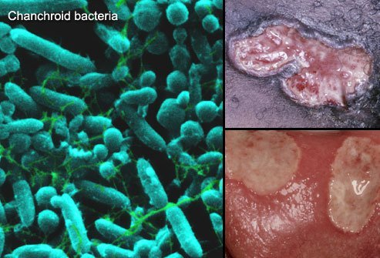

**Aetiology;**

Gram-negative rod H ducreyi.( **Haemophilus ducreyi** is the gram-negative, facultative anaerobic bacterium that causes chancroid.)

Exposure is usually through coitus, but accidentally acquired lesions of the hands have occurred.

The incubation period is short: the lesion usually appears in 3–5 days or sooner. An increased rate of HIV infection has been reported among patients with this genital ulcer disease; chancroid is a cofactor for HIV transmission.

Moreover, 10% of patients with genital chancroid may have coinfection with herpes or syphilis.

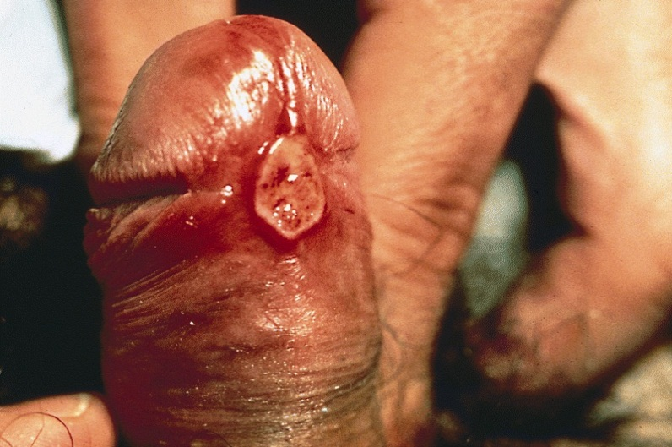

**Clinical Features of Chancroid;**

1.     Vesico pustule on the pudendum, vagina, or cervix. Later, it degenerates into a saucer-shaped ragged ulcer circumscribed by an inflammatory wheal.

2.    Typically, the lesion is very tender and produces a heavy, foul discharge that is contagious.

3.    A cluster of ulcers may develop. Lesions typically occur on the vulva, cervix, and perianal area in women.

4.    Painful inguinal adenitis is noted in over 50% of cases. The buboes may become necrotic and drain spontaneously.

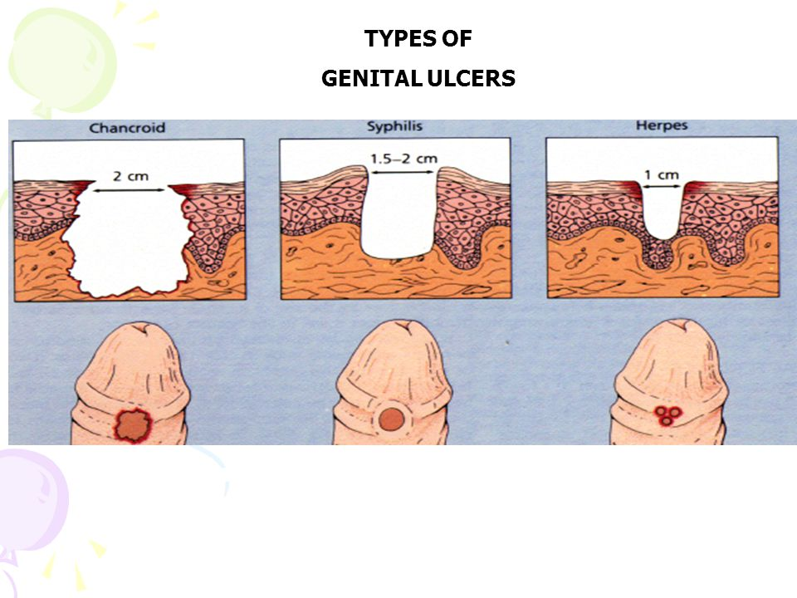

**Laboratory Dx;**

Syphilis must first be ruled out.

1)    Demonstration of the organism in pathological specimens (Vulval smear- from the ulcer, pus)

                     i.        Clinical diagnosis is more reliable than smears or cultures because of the difficulty of isolating this organism.

                    ii.        Isolation of H ducreyi is diagnostic, but isolation occurs in less than one-third of cases.

                   iii.        Aspirated pus from a bubo is the best material for culture.

                   iv.        Serum adsorption enzyme immunoassays have been evaluated and currently have a limited sensitivity.

                    v.        Polymerase chain reaction (PCR) testing of genital samples is becoming widely available.

                   vi.        Multiplex PCR is a technique that can simultaneously screen for HSV, Treponemapallidum, and H ducreyi using a single swab but is not yet commercially available.

2)   RPR-Rapid Plasminogen Reagen to rule out syphilis.

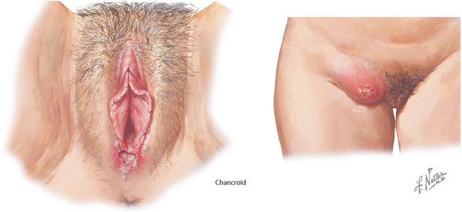

**Differential Diagnosis of chancroid;**

1.     Syphilis,

2.    Granuloma inguinale,

3.    Lymphogranuloma venereum,

4.    Herpes simplex may coexist with chancroid and must be ruled out.

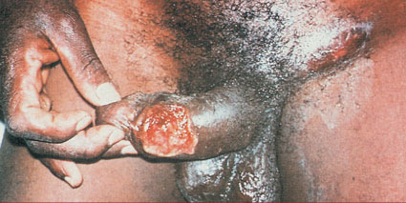

**Prevention of chancroid;**

Chancroid is a notifiable disease in some settings.

Routine antibiotic prophylaxis is not warranted.

Condoms can give protection.

Liberal use of soap and water is relatively effective. Education is essential.

**4Cs**

                     i.        Counselling and education.

                    ii.        Condom promotion.

                   iii.        Compliance to medication.

                   iv.        Contact tracing.

**Treatment of chancroid;**

1)    Good personal hygiene is important.

a.    The early lesions should be cleansed with mild soap solution.

b.    Sitz baths are beneficial.

2)   Antibiotic Treatment

Guidelines issued by the Centers for Disease Control and Prevention (CDC) for genital chancroid are as follows.

Recommended regimen;

* Azithromycin 1 g orally once;
* Ceftriaxone 250 mg intramuscularly (IM) as a single dose;
* Erythromycin 500 mg orally 3 times daily for 7 days;
* Ciprofloxacin 500 mg orally twice daily for 3 days in nonpregnant patients over age 17 years who are not lactating. The course may have to be repeated.
* Fluctuant lymph nodes may need to be aspirated through normal adjacent skin. Incision and drainage of the nodes is not recommended because it will delay healing.

**Prognosis**

Untreated or poorly managed cases of chancroid may persist, and secondary infection may develop.

Frequently, the ulcers heal spontaneously. They should improve within 7–10 days. If no improvement is noted, coinfection, HIV, resistant strains, and noncompliance must be considered. If not treated, they may cause deep scarring with sequelae in men.

**1.4: GRANULOMA INGUINALE (DONOVANOSIS)**

Granuloma inguinale is a chronic ulcerative granulomatous disease that usually develops in the vulva, perineum, and inguinal regions.

**Aetiology;**

The causative organism is Calymmatobacterium granulomatis (Donovan body).

Donovan bodies are bacteria encapsulated in mononuclear leukocytes.

Transmission is via coitus, and the incubation period is 8–12 weeks.

**Clinical features of Granuloma inguinale;**

Although granuloma inguinale most often involves the skin and subcutaneous tissues of the vulva and inguinal regions, cervical, uterine, orolabial, and ovarian sites have been reported.

1.     A malodorous discharge is characteristic.

2.    The disorder often begins as a papule, which then ulcerates, with the development of a beefy-red granular zone with clean, sharp edges. The ulcer shows little tendency to heal, and the patient usually has no local or systemic symptoms. Healing is very slow, and satellite ulcers may unite to form a large lesion.

3.    Lymphatic permeation is rare, but lymphadenitis may result when the cutaneous lesion becomes superimposed on lymphatic channels. Inguinal swelling is common, with late formation of abscesses (buboes).

4.    Rarely, granuloma inguinale is manifested by chronic cervical lesions. These lesions usually take the form of redness or ulceration, or they form granulation tissue.

5.    They produce a chronic inflammatory exudate characterized histologically by lymphocytes, giant cells, and histiocytes. They may mimic carcinoma of the cervix and must be distinguished from this as well as other neoplastic diseases.

6.    The chronic ulcerative process may involve the urethra and the anal area, causing marked discomfort.

7.    Introital contraction may make coitus difficult or impossible; walking or sitting may become painful. The possibility of the coexistence of another venereal disease must be considered. Spread to other areas occurs in approximately 7% of patients.

**Laboratory Findings;**

1.     Direct smear from beneath the surface of an ulcer may reveal gram-negative bipolar rods within mononuclear leukocytes. These are seen best in Wright-stained smears.

2.    When smears are negative, a biopsy specimen should be taken. Biopsy of the lesion generally shows granulation tissue infiltrated by plasma cells and scattered large macrophages with rod-shaped cytoplasmic inclusion bodies (Mikulicz cells).

3.    Pseudoepitheliomatous hyperplasia often is seen at the margin of the ulcer.

4.    Demonstrating, in biopsy or smear material stained with Wright's, Giemsa's, or silver stain, large mononuclear cells having one or more cystic inclusions containing the so-called Donovan bodies—small round or rod-shaped particles that stain purple in traditional hematoxylin and eosin preparations.

**Prevention of Granuloma inguinale;**

Personal hygiene is the best method of prevention. Therapy immediately after exposure may abort the infection.

**Rx of granuloma inguinale;**

1.     Trimethoprim-sulfamethoxazole (CTX) 960mg BD X 3/52

2.    Doxycycline 100 mg BD X 3/52.

3.    Ciprofloxacin 750 mg BD X 3/52.

4.    Erythromycin 500 QID X  2–3/52.

5.    Azithromycin 1 g OD  per week for 3 weeks.

Penicillin is not effective.

Sex partners must be considered for treatment.

Partners who had sexual contact during the 60 days preceding the onset of symptoms or are clinically symptomatic should be treated by 1 of the regimens.

Special consideration for HIV and gravid women should be made. Recommendations to add intravenous gentamicin to the oral protocol have been made.

**1.5: LYMPHOGRANULOMA VENEREUM (LGV)**

**Aetiology;**

The causative agent of lymphogranuloma venereum is 1 of the aggressive L serotypes (L1, L2, or L3) of Chlamydia trachomatis.

Transmission is via sexual contact; men are affected more frequently than are women (6:1). The incubation period is 7–21 days.

**Clinical features;**

1.     A vesicopustular eruption which may go undetected.

2.    Inguinal (and vulvar) ulceration,

3.    Lymphedema,

4.    Genital pain.

5.    During the inguinal bubo phase, the groin is exquisitely tender.

6.    A hard cutaneous induration (red to purplish-blue) is a notable feature. This usually occurs within 10–30 days after exposure and may be bilateral.

7.    Anorectal lymphedema occurs early; defecation is painful, and the stool may be blood-streaked.

8.    Vaginal narrowing and distortion may end in severe dyspareunia.

9.    In the late phase, systemic symptoms;

1. Fever
2. Headache
3. Arthralgia,
4. Chills,
5. Abdominal cramps.

**Laboratory Features of LGV.**

1.     Isolating C trachomatis from appropriate specimens and confirming the immunotype. These procedures are seldom available, so less specific tests are used.

2.    A complement fixation test using a heat-stable antigen that is group-specific for all Chlamydia species is available. This test is positive at a titer  1:16 in more than 80% of cases of lymphogranuloma venereum. If acute or convalescent sera are available, a rise in titer is particularly helpful in making the diagnosis. Application of the microimmunofluorescent test may also be useful.

**Differential Diagnosis of LGV;**

As with any disseminated disease, the systemic symptoms of lymphogranuloma venereum may resemble;

1.     Meningitis,

2.    Arthritis,

3.    Pleurisy,

4.    Peritonitis.

5.    Granuloma inguinale,

6.    Tuberculosis,

7.    Early syphilis,

8.    Chancroid.

In the case of colonic lesions, proctoscopic examination and mucosal biopsy are needed to rule out carcinoma, schistosomiasis, and granuloma inguinale.

**Complications of LGV;**

1)    Perianal scarring

2)   Rectal strictures—late complications—can involve the entire sigmoid, but the urogenital diaphragm is rarely involved.

3)   Vulvar elephantiasis (esthiomene) produces marked distortion of the external genitalia.

**Prevention;**

Avoiding infectious contact with a carrier is achieved by use of a condom or by refraining from coitus.

Definite exposure can be treated with sulfonamides or tetracyclines.

**Rx of LGV;**

**1.    Chemotherapy**

1)    Doxycycline 100 mg bd x 21/7.If disease persists, the course should be repeated.

2)   Erythromycin 500 mg QID X 21/7.

**2.   Local and Surgical Treatment**

1)    Anal strictures should be dilated manually at weekly intervals.

2)   Severe stricture may require diversionary colostomy.

3)   If the disease is arrested, complete vulvectomy may be done for cosmetic reasons.

4)   Abscesses should be aspirated, not excised.

**1.6: SYPHYLLIS**

**Aetiology;**

Treponema pallidum;

**Forms of Syphyllis;**

**1)   Primary Syphilis**

                     i.        Painless genital sore (chancre) on labia, vulva, vagina, cervix, anus, lips, or nipples.

                    ii.        Painless, rubbery, regional lymphadenopathy followed by generalized lymphadenopathy in the third to sixth weeks.

**Laboratory findings in primary syphyllis**;

·         Dark-field microscopic findings.

·         Positive serologic test in 70% of cases.

**2)   Secondary Syphilis**

                     i.        Bilaterally symmetric extragenital papulosquamous eruption.

                    ii.        Condyloma latum, mucous patches.

                   iii.        Lymphadenopathy.

Laboratory findings in secondary syphyllis;

·         Dark-field findings positive in moist lesions.

·         Positive serologic test for syphilis.

**3)   Tertiary Syphilis**

                                     i.        Cardiac,

                                    ii.        Neurologic,

                                   iii.        Ophthalmic, and

                                   iv.        Auditory lesions.

                                    v.        Gummas.

**4.  Congenital Syphilis**

1)    History of maternal syphilis.

2)   Positive serologic test for syphilis.

3)   Stigmata of congenital syphilis (eg, x-ray changes of bone, hepatosplenomegaly, jaundice, anemia).

4)   Normal examination or signs of intrauterine infection.

5)   Often stillborn or premature.

6)   Enlarged, waxy placenta.

The course of syphilis is unaltered by pregnancy, but misdiagnoses are common.

**Syphylitic chancre in congenital syphilis**;

The chancre is often unnoticed or internal and not brought to medical attention. Chancres, mucous patches, and condyloma lata are often thought to be herpes genitalis. The dermatoses can resolve prior to diagnosis, or they may be misdiagnosed.

The effect of syphilis on pregnancy outcome can be profound.

**Risk of congenital  infection;**

The risk of fetal infection depends on;

1.     The degree of maternal spirochetemia (greater in the secondary stage than in the primary or latent stages).

2.    The gestational age of the fetus.

Treponemes may cross the placenta at all stages of pregnancy, but fetal involvement is rare before 18 weeks because of fetal immunoincompetence.

After 18 weeks, the fetus is able to mount an immunologic response, and tissue damage may result. The earlier in pregnancy the fetus is exposed, the more severe the fetal infection and the greater the risk of premature delivery or stillbirth.

Antepartum infection in late pregnancy does not necessarily result in congenital infection, as only 40–50% of such infants will have definite congenital infection. Placental infection can occur with resultant endarteritis, stromal hyperplasia, and immature villi.

**Placenta in congenital syphyllis;**

Grossly, the placenta looks;

1)    Hydropic

a.    Pale yellow,

b.    Waxy, and

c.     Enlarged).

2)   Polyhydramnios- Because hydramnios is frequently associated with symptomatic congenital infection, fetuses are ultrasonographically followed throughout pregnancy.

Because the antibodies from the maternal compartment are of the immunoglobulin (Ig)G class, they freely cross the placenta, giving most neonates a reactive serologic test if the mother's test was reactive. With symptomatic neonatal infection, often the cord blood serologic test will be higher in titer than the maternal test. No clinically reliable neonatal IgM serologic test is available. Other diagnostic aids include long-bone survey and lumbar puncture, which may help diagnose asymptomatic systemic infection requiring more intense therapy.

**A child with congenital syphyllis;**

The newborn may have

1)    Lymphadenitis.

2)   Hepatomegally

3)   Splenomegally.

4)   The bones usually reveal signs of osteochondritis and an irregular epiphyseal juncture on x-ray.

5)   The eyes, central nervous system structures, and other organs may reveal abnormalities at birth, or defects may develop later in untreated cases.

Any infant with the stigmata of syphilis should be placed in isolation until a definite diagnosis can be made and treatment administered.

Newborns with congenital syphilis may appear healthy at birth but often develop symptoms weeks or months later. Examine the body for stigmata of syphilis at intervals of 3 weeks to 4 months. If the mother's serologic test is positive at delivery, the baby's test will also be positive. Obtain serial quantitative serologic tests of the infant's blood for 4 months. A rising titer indicates congenital syphilis, and treatment is indicated.

**5.  Latent Syphilis**

1.     History or serologic evidence of previous infection.

2.    Absence of lesions.

3.    Serologic test usually reactive; titer may be low.

**Pathology of syphyllis;**

Syphilis is caused by T pallidum, which is transmitted by direct contact with an infectious moist lesion.

Treponemes pass through intact mucous membranes or abraded skin.

Pathological evolution and history of infection;

1.     Ten to 90 days after the treponemes enter; A primary lesion (chancre) develops. The chancre persists for 1–5 weeks and then heals spontaneously, but it may persist with signs of secondary disease. Serologic tests for syphilis are usually nonreactive when the chancre first appears but become reactive 1–4 weeks later.

2.    Two weeks to 6 months (average, 6 weeks)

After the primary lesion appears, the generalized cutaneous eruption of secondary syphilis may appear. The skin lesions heal spontaneously in 2–6 weeks. Serologic tests are almost always positive during the secondary phase.

3.    Latent syphilis;

 May follow the secondary stage and may last a lifetime, or tertiary syphilis may develop. The latter usually becomes manifest 4–20 or more years after disappearance of the primary lesion.

**Untreated syphyllis/chronic complications**;

In one-third of untreated cases, the destructive lesions of late (tertiary) syphilis develop. These involve

1)    Skin or bone (gummas),

2)   The cardiovascular system (aortic aneurysm or insufficiency),

3)   The nervous system (meningitis, tabes dorsalis, paresis).

The complications of tertiary syphilis are fatal in almost one-fourth of cases, but one-fourth never show any ill effects.

**Laboratory Findings;**

**1.    Identification of the Organism**

1)    Dark-field examination of specimens from cutaneous lesions, but the recovery period of the treponeme is brief; in most cases, diagnosis depends on the history and serologic tests.

2)   An immunofluorescent technique is now available for dried smears.

3)   Silver staining for T pallidum of biopsy specimens, placental sections, or autopsy material may confirm the diagnosis in difficult cases. Motile spirochetes can be identified in amniotic fluid obtained transabdominally in women with syphilis and fetal death.

4)   PCR is extremely specific for detection of T pallidum in amniotic fluid and neonatal serum and spinal fluid.

5)   Newer techniques involving molecular methods are now being used to diagnosis early syphilis. Multiplex PCR is such an assay that can simultaneously detect T pallidum, H ducreyi, and herpes simplex but is not yet commercially available.

**2.   Serologic Tests**

Diagnostic tests after the primary or secondary moist lesion has disappeared are confined largely to serologic testing. Serologic tests become positive several weeks after the primary lesion appears.

1)    Nontreponemal Tests;

Nontreponemal tests currently in use are flocculation procedures that include the;

a.    VDRL slide test,

b.    Rapid reagin test(RPR-Rapid Plasminogen Reagen).

c.     Automated reagin test for screening procedures in the field. The latter tests are more sensitive but less specific than the VDRL.

If they are positive, the activity should be verified, and the degree of reactivity should be checked by the VDRL test. Complement fixation tests (eg, Kolmer) are no longer considered usefull.

The VDRL test (the nontreponemal test in widest use) generally becomes positive 3–6 weeks after infection, or 2–3 weeks after the appearance of the primary lesion; it is almost invariably positive in the secondary stage.

The VDRL titer is usually high in secondary syphilis and tends to be lower or even nil in late forms of syphilis, although this is highly variable. A 4-fold falling titer in treated early syphilis or a falling or stable titer in latent or late syphilis indicates satisfactory therapeutic progress.

False-positive serologic reactions are frequently encountered in a wide variety of situations, including;

1. Collagen diseases,
2. Infectious mononucleosis,
3. Malaria,
4. Febrile diseases,
5. Leprosy,
6. Vaccination,
7. Drug addiction,
8. Old age,
9. Pregnancy.

False-positive reactions are usually of low titer and transient and may be distinguished from true-positive results by specific treponemal antibody tests.

**3.   Treponemal Antibody Tests;**

                     i.        FTA-ABS test and

                    ii.        Microhemagglutination assay for Treponema pallidum (MHA-TP.

These detect antibody against Treponema spirochetes.

Both tests are more sensitive and specific than nontreponemal tests (except the MHA-TP test with primary disease.

These tests remain positive despite therapy, so they are not given in titers or used to follow serologic response to treatment.

**Differential Diagnosis of syphyllis;**

Primary syphyllis;

1.     Chancroid,

2.    Granuloma inguinale,

3.    Lymphogranuloma venereum,

4.    Herpes genitalis,

5.    Carcinoma,

6.    Scabies,

7.    Trauma,

8.    Lichen planus,

9.    Psoriasis,

10.  Drug eruption,

11.   Aphthosis,

12.  Mycotic infections,

13.  Reiter's syndrome, and

14.  Bowen's disease.

Secondary syphyllis;

1.     Pityriasis rosea,

2.    Psoriasis,

3.    Lichen planus,

4.    Tinea versicolor,

5.    Drug eruption,

6.    Parasitic infections,

7.    Iritis,

8.    Neuroretinitis,

9.    Condyloma acuminatum,

10.  Acute exanthems,

11.   Infectious mononucleosis,

12.  Alopecia, and

13.  Sarcoidosis.

**Prevention;**

1)    4Cs.

2)   If the patient is known to have been exposed to syphilis, do not wait for the disease to develop to the clinical or reactive serologic stage before giving preventive treatment. Even so, every effort should be made to reach a diagnosis, including a complete physical examination, before administering preventive treatment. It is recommended that any patient who is exposed and becomes symptomatic within 90 days of sexual contact and is seronegative should still be treated. Also, if the exposure occurred more than 90 days earlier and seroconversion takes place, the exposed person should be treated.

3)   If the duration since exposure is unknown and the nontreponemal antibody titer is greater than 1:32, treatment is indicated.

4)   All pregnant women should undergo a routine serologic test for syphilis at the first visit. The test should be repeated between 28 and 32 weeks' gestation in high-risk regions. If the test result is positive, attention must be given to the patient's prior serologic test and therapy (if any) for syphilis. If doubt exists as to whether the patient has active syphilis, repeat therapy is far better than the risk of congenital syphilis.

**Rx of Syphyllis;**

Early Syphilis and Contacts

Primary, secondary, and early latent syphilis (<1 year's duration):

1.     Benzathine penicillin G 2.4 million units IM once.

2.    Tetracycline hydrochloride 500 mg QID X 2/52

3.    Doxycycline 100mg BD X 2/52.

4.    For nonpregnant penicillin-allergic patients. Erythromycin estolate should not be administered to pregnant women because of potential drug-related hepatotoxicity.

Ceftriaxone 1 g daily IM or IV for 8–10 days may be effective, but data on this regimen are limited.

Late Syphilis

Includes latent syphilis of indeterminate duration or more than 1 year's duration, except neurosyphilis.

1.     Benzathine penicillin G 2.4 million units IM weekly for 3 successive weeks (7.2 million units total).

2.    Tetracycline hydrochloride 500 mg orally QID X 2/52.

3.    Doxycycline 100mg BD X 2/52.

**Rx of Syphilis in Pregnancy;**

Treat as indicated above, except that tetracycline or erythromycin is not recommended.

If serologic tests are equivocal (eg, possible biologic false-positive result), it is better to err on the side of early treatment.

Because of the increased risk for treatment failure, a second dose of 2.4 million units of penicillin IM is often recommended.

Penicillin-allergic patients can be given oral desensitization therapy using gradually larger doses of phenoxymethyl penicillin suspension to achieve a temporary tolerant state that allows parenteral penicillin therapy. This is particularly useful in circumventing compliance problems due to hyperemesis or drug-induced gastric upset.

**Rx of Congenital Syphilis;**

Adequate maternal treatment before 16–18 weeks' gestation prevents congenital syphilis. Treatment thereafter may arrest fetal syphilitic infection, but some stigmata may remain.

1.     Benzathine penicillin G 50,000 U/kg IM as a single injection, for asymptomatic infants without neurosyphilis.

2.    Aqueous crystalline penicillin G 50,000 U/kg IV every 8–12 hours, or procaine penicillin G 50,000 U/kg IM once daily for 10–14 days, for symptomatic infants or those with neurosyphilis.

**Jarisch-Herxheimer Reaction in syphyllis;**

A febrile reaction may occur in 50–75% of patients with early syphilis treated with penicillin.

This occurs 4–12 hours after injection and is completed by 24 hours. Its cause is uncertain but may involve a release of treponemal toxic products upon organism lysis. The reaction is generally benign but may trigger labor or fetal distress. Prophylaxis with antipyretics or corticosteroids is of unknown value.

**Syphyllis in HIV;**

No specific changes in treatment are currently necessary, but close follow-up is necessary to ensure adequate treatment.

Recommendations include serology tests every 3 months for 1 year and twice during the second year.

**1.7: VAGINITIS**

This is generally inflammation of the vagina.

Vaginitis is a clinical syndrome characterized by;

                     i.        Vaginal discharge,

                    ii.        Vulvar irritation, or

                   iii.        Malodorous discharge.

**Classification of vaginitis;**

This is often broken down into 2 entities:

1)    Infectious vaginitis and

2)   Atrophic vaginitis.

**Infectious vaginitis;**

Infectious vaginitis is most frequently caused by 1 of 3 diseases:

1.     Trichomoniasis,

2.    Bacterial vaginosis, or

3.    Candidiasis.

**Bacterial Vaginosis (Corynebacterium vaginale Vaginitis; Gardnerella vaginalis Vaginitis)**

Although bacterial vaginosis is the most prevalent vaginal infection, almost 50% of affected women are asymptomatic.

The term bacterial vaginosis refers to the intricate changes of vaginal bacterial flora with a loss of lactobacilli, an increase in vaginal pH (pH > 4.5), and an increase in multiple anaerobic and aerobic bacteria.

**Clinical criteria for diagnosing bacterial vaginosis;**

     i.        Homogeneous white, noninflammatory discharge;

    ii.        Microscopic presence of > 20% clue cells;

   iii.        Vaginal discharge with pH > 4.5; and

   iv.        Fishy odor with or without addition of 10% potassium hydroxide (KOH).

**The pathogen in bacterial vaginosis;**

Gardnerella vaginalis (formerly designated Corynebacterium vaginale and Haemophilus vaginalis) is a small, nonmotile, nonencapsulated, pleomorphic rod that stains variably with Gram's stain.

It may be spread by sexual contact and, although of low virulence, causes vaginitis.

The disorder may be atypical and even more troublesome when G vaginalis coexists with more virulent organisms.

G vaginalis is not the only cause of bacterial vaginosis.

**Fishy odour in bacterial vaginosis;**

The characteristic fishy odor of bacterial vaginosis is due to anaerobic bacteria, such as;

1.     Bacteroides,

2.    Prevotella,

3.    Peptostreptococcus, and

4.    Mobiluncus spp., and

5.    Genital mycoplasmas.

G vaginalis infection is often overlooked. It may be suspected on the basis of the microscopic appearance of unstained exfoliated vaginal cells in a wet preparation that appears to be dusted with many small dark particles, actually G vaginalis organisms.

These "clue cells" are presumptive evidence of the presence of this organism. In case of mixed infection (eg, with Candida albicans), it may not be possible to make the diagnosis except by culture.

Gram's stain is another method useful for making the diagnosis of bacterial vaginosis.

**Bacterial vaginosis and adverse pregnancy outcome;**

Observational studies have consistently shown an association between bacterial vaginosis and adverse pregnancy outcomes, including;

1)    Preterm delivery,

2)   Preterm premature rupture of membranes,

3)   Spontaneous abortion, and

4)   Preterm labor.

However, 2 large randomized, placebo-controlled trials demonstrated that treatment of bacterial vaginosis in asymptomatic, pregnant women with metronidazole does not prevent preterm deliveries.

The CDC recommends that pregnant women with a history of preterm delivery and asymptomatic bacterial vaginosis be evaluated for treatment.

**Rx of bacterial vaginosis;**

1.     Oral metronidazole 500 mg BD X 1/52.

2.    Antibacterial gels/creams

a.    Clindamycin cream 2%, 1 applicatorful (5 g) intravaginally at night for 7 days; and

b.    Metronidazole gel 0.75%, 1 applicatorful (5 g) intravaginally once daily for 5 days.

3.    Oral metronidazole 2 g in a single dose;

4.    Clindamycin 300 mg BD X 1/52

5.    Clindamycin ovules 100 g intravaginally once at bedtime for 3 days.

Four randomized controlled trials have demonstrated overall cure rates of 95% for the 7-day metronidazole regimen and 84% for the single 2-g regimen.

During pregnancy, oral treatment is preferred to local agents to ensure adequate tissue levels of the bactericidal drug. The recommended regimen is metronidazole 250 mg orally 3 times daily for 7 days or clindamycin 300 mg orally twice daily for 7 days.

**1.8: URETHRITIS AND CERVICITIS**

**Aetiology;**

Urethral mucopurulent or purulent discharge is commonly caused by

1.     Neisseria gonorrhoeae,

2.    C trachomatis, or

3.    Genital herpes.

Although asymptomatic infections are common, some patients experience slow-onset dysuria with vaginal discharge and/or irregular bleeding.

Urethritis and cervicitis are often coinfections. Both are reportable STDs, and clinicians must mandate that partners of patients obtain diagnostic and therapeutic interventions.

Cervicitis is an inflammation of either the ectocervical cells or the glandular cells composing the cervical epithelium.

The ectocervical squamous cells are contiguous with the vaginal epithelium and can be infected by the same organisms that cause inflammatory vaginitis. The glandular cells of the endocervix are more commonly inflamed by N gonorrhoeae and C trachomatis.

**1)   Gonorrhea;**

Practical essentials;

1. Most affected women are asymptomatic carriers.
2. Purulent vaginal discharge.
3. Urinary frequency and dysuria.
4. May progress to pelvic infection or disseminated infection.

**Aetiology of gonorrhea**;

Neisseria gonorrhoeae.

This is a gram-negative diplococcus that forms oxidase-positive colonies and ferments glucose.

The organism may be recovered from the urethra, cervix, anal canal, or pharynx. It causes ascending infections.

N gonorrhoeae is rapidly killed by drying, sunlight, heat, and most disinfectants.

The columnar and transitional epithelium of the genitourinary tract is the principal site of invasion. The organism may enter the upper reproductive tract, causing salpingitis with its attendant complications.

It has been estimated that after exposure to an infected partner, 20–50% of men and 60–90% of women become infected.

Without therapy, 10–17% of women with gonorrhea develop pelvic infection.

Depending on the geographic location and population involved, N gonorrhoeae is often present with other STDs.

Traditionally, women with gonorrhea are considered to be at risk for incubating syphilis. It has been shown that 20–40% also have Chlamydia infection.

**Clinical Features of gonorrhea;**

1.     Early Symptoms

1)    Most women with gonorrhea are asymptomatic.

2)   Vaginal discharge,

3)   Urinary frequency or dysuria, and

4)   Rectal discomfort.

The incubation period is only 3–5 days.

The vulva, vagina, cervix, and urethra may be inflamed and may itch or burn. Specimens of discharge from the cervix, urethra, and anus should be taken for culture from the symptomatic patient.

A stain of purulent urethral exudate may demonstrate gram-negative diplococci in leukocytes. Similar findings in a purulent cervical discharge are less conclusively diagnostic of N gonorrhoeae.

**Gonorrhoea Bartholinitis/Bartholins abscess;**

Unilateral swelling in the inferior lateral portion of the introitus suggests involvement of Bartholin's duct and gland.

In early gonococcal infections, the organism may be recovered by gently squeezing the gland and expressing pus from the duct.

Enlargement, tenderness, and fluctuation may develop, signifying abscess formation. N gonorrhoeae is then less frequently recovered; however, the prevalence of infection with other bacteria merits a search for these pathogens. Spontaneous evacuation of pus often occurs if the incision is not drained. The infection may result in asymptomatic cyst formation

**Gonorrhoea Anorectal Inflammation/Proctitis;**

1. Anal itching,
2. Anal pain,
3. Anal discharge, or
4. Bleeding occurs rarely.

Most women are asymptomatic and acquire infection by perineal spread of vaginal secretions rather than by anal intercourse

**Gonorrhoea Pharyngitis;**

Acute pharyngitis and tonsillitis rarely occur; most infections are asymptomatic.

**Disseminated gonococcal Infection;** For unknown reasons, asymptomatic carriers can develop systemic infection. Commonly, a triad of

1. Polyarthralgia,
2. Tenosynovitis, and
3. Dermatitis is seen, or
4. Purulent arthritis without dermatitis.

Septicemia is more common in the former clinical setting and N gonorrhoeae cultured from joint aspirates in the latter. Endocarditis and meningitis have been described.

**Gonococcal Conjunctivitis;**

In adults, ophthalmic infection is usually due to autoinoculation.

Ophthalmia neonatorum may result from delivery through an infected birth canal.

**Gonococcal Vulvovaginitis in Children;**

Gonococcal invasion of nonkeratinized membranes in prepubertal girls produces severe vulvovaginitis.

The typical sign is a purulent vaginal discharge with dysuria.

The genital mucous membranes are red and swollen. Infection is commonly introduced by adults, and in such cases the physician must consider the possibility of child abuse.

**Laboratory Dx of Gonorrhoea;**

A presumptive diagnosis of gonorrhea can be made based on examination of the stained smear; however, confirmation requires positive identification on selective media.

1.     Secretions are examined under oil immersion for presumptive identification which identifies Gram-negative diplococci.

2.    Culture which yield gram negative diplococci that are oxidase-positive and obtained from selective media (Thayer-Martin or Transgrow) usually signify N gonorrhoeae.

3.    Carbohydrate fermentation tests may be performed, but in addition to being time-consuming and expensive, they occasionally yield other species of Neisseria. Therefore, cultures are reported as "presumptive for N gonorrhoeae."

4.    Chlamydial cultures or direct smear testing (ELISA or immunofluorescent staining) of the cervix and a serologic test for syphilis should also be obtained.

5.    Other techniques for detecting gonorrhea include enzyme immunoassay from cervical swab or urine specimens, DNA probes from endocervical swabs, and nucleic acid amplification tests (NAATs) from endocervical swabs, liquid Papanicolaou (Pap) specimens, vaginal swabs, and urine specimens.

**Complications of Gonorrhoea;**

**1)**Salpingitis and the complications that may arise from salpingitis (Salpingitis-Peritonitis).

**2)**Cervicitis- gonorrhoeae can be recovered from the cervix in approximately 50% of women with salpingitis.

**3)**It is important to note that asymptomatic carriers can also develop tubal scarring, infertility, and increased risk for ectopic gestations.

**Rx of gonorrhoea**

Any patient with gonorrhea must be suspected of having other STDs (eg, syphilis, HIV, and chlamydial infection) and managed accordingly.

Treatment should cover N gonorrhoeae, C trachomatis, and incubating syphilis.

Dual therapy has contributed greatly to the declining prevalence of chlamydial infections.

Therefore, if chlamydial infection is not ruled out, the following regimens should be given with doxycycline or azithromycin.

**a)   Adults/Non pregnant;**

1)    Ceftriaxone 125 mg IM once, plus doxycycline 100 mg orally twice daily for 7 days

2)   Azithromycin 1 g orally in a single dose if chlamydial infection is not ruled out;

3)   Cefixime 400mg orally once, plus doxycycline or azithromycin as above;

4)   Ofloxacin 400mg,

5)   Levofloxacin 250 mg,

6)   Ciprofloxacin 500mg orally once in nonpregnant, nonlactating patients over 17 years old, plus doxycycline or azithromycin as above.

**b)   Pregnancy;**

Pregnant women should not be treated with quinolones or tetracyclines.

They should be treated with a recommended or alternate cephalosporin.

If cephalosporins are not tolerated, spectinomycin 2 g IM should be given along with treatment for diagnosed or presumptive C trachomatis.

The incidence of penicillinase-producing strains of N gonorrhoeae (PPNGs) is increasing and is spreading from coastal areas to the center of the United States. They are unresponsive to previously recommended conventional therapy such as penicillin, ampicillin, or amoxicillin. Currently recommended cephalosporins and quinolones and regimens with -lactamase inhibitors are effective therapy against PPNG strains.

**c)   Rx of disseminated gonococcal infections;**

Disseminated gonococcal infection should be treated in the hospital initially.

Evidence for endocarditis or meningitis should be sought.

Recommended regimens include;

1. Ceftriaxone 1 g IM or IV every 24 hours,
2. Cefotaxime or ceftizoxime 1 g IV every 8 hours.
3. For patients with -lactamase allergy, spectinomycin 2 g IM every 12 hours can be used. Testing for chlamydia should be performed or therapy given.

**d)   Rx of gonorrhea in Neonates and Children;**

Infants born to women with untreated gonorrhea should be treated with

·         Ceftriaxone 25–50 mg/kg IV or IM, not to exceed 125 mg. It should be given cautiously to premature or hyperbilirubinemic infants.

**Prognosis of  Syphyllis;**

The prognosis is excellent for patients with gonorrhea who receive prompt treatment.

Infertility may result from even a single episode.

**1.9: CHLAMYDIA**

**Practice essentials;**

Genital infection with this organism is the most common sexually transmitted bacterial disease in women.

Chlamydiae are obligate intracellular microorganisms that have a cell wall similar to that of gram-negative bacteria.

They are classified as bacteria and contain both DNA and RNA. They divide by binary fission, but like viruses they grow intracellularly.

They can be grown only by tissue culture. With the exception of the L serotypes, chlamydiae attach only to columnar epithelial cells without deep tissue invasion. As a result of this characteristic, clinical infection may not be apparent.

For example, infections of the eye, respiratory tract, or genital tract are accompanied by discharge, swelling, erythema, and pain localized to these areas only. C trachomatis infections are associated with many adverse sequelae due to chronic inflammatory changes as well as fibrosis (eg, tubal infertility and ectopic pregnancy).

The proposed mechanism for the pathogenesis of chlamydial disease is an immune-mediated response. This mechanism has been supported C trachomatis vaccine studies in humans and monkeys as well as other animal model studies.

Evidence indicates that a 57-kDa chlamydial protein, which is a member of 60-kDa heat shock proteins, plays a role in the immunopathogenesis of chlamydial disease.

**Risk factors for chlamydia;**

Certain factors may be predictive of women with a greater likelihood of acquiring C trachomatis.

1.     Sexually active women younger than 20 years have chlamydial infection rates 2–3 times higher than the rates of older women.

2.    The number of sexual partners .

3.    Lower socioeconomic status are associated with higher chlamydial infection rates.

4.    Persons who use barrier contraception are less frequently infected by C trachomatis than are those who use no contraception.

5.    Women who use oral contraceptives may have a higher incidence of cervical infection than women not using oral contraceptives.

Cervical infection in pregnant women varies from 2–24% and is most prevalent in young, unmarried women of lower socioeconomic status in inner-city environments.

**Screening for chlamydia;**

The CDC recommends screening sexually active adolescent girls at their routine yearly gynecologic examination, as well as women 20–24 years old, especially those who have new or multiple partners, and those who inconsistently use barrier contraceptives.

**Clinical features of chlamydial infections;**

1.     Women with chlamydial infection not uncommonly are asymptomatic.

2.    Women with cervical infection generally have a mucopurulent discharge with hypertrophic cervical inflammation. Salpingitis may be unassociated with symptoms.

**Laboratory Dx of Chlamydia;**

The diagnosis of chlamydial infection is based solely on laboratory tests.

1)    Cell culture isolation has a sensitivity of 70–90%; however, this specialized modality is not widely available. Cell culture is the detection method of greatest specificity (almost 100%), but the cost can be prohibitive, and a 3- to 7-day delay in diagnosis is required.

2)   Serologic methods, either the complement fixation or microimmunofluorescence test, are not totally accurate, as 20–40% of sexually active women have positive antibody titers. In fact, most women with microimmunofluorescent antibody do not have a current infection.

3)   Direct smear fluorescent antibody testing requires a fluorescence microscope, and processing time is only 30–40 minutes. Sensitivity is 90% or higher, with a specificity of 98% or higher if an experienced microscopist and a satisfactory specimen are available. This test appears to be the most promising, and when tissue samples (endometrial or uterine tube) are being evaluated, it has been reported to be more accurate.

4)   PCR, ligase chain reaction, and current DNA probes used for detection of C trachomatis may be more rapid and less expensive. Nucleic acid hybridization methods (DNA probe) require only 2–3 hours of processing time. The DNA probe assay is specific for C trachomatis; cross-reactivity with C pneumoniae and C psittaci has not been reported. To ensure high specificity, a competitive probe assay has been produced and is currently being evaluated in clinical trials. Recent reports indicate PCR positivity with negative culture. PCR may be the most sensitive and specific test method for chlamydia.

**Differential Diagnosis of Chlamydia;**

     i.        Mucopurulent cervicitis.

    ii.        Salpingitis.

**Complications of chlamydia;**

1)    Infertility due to tubal obstruction and ectopic pregnancy, are the most dire complications of these infections.

2)   Pregnant women with cervical chlamydial infection can transmit infections to their newborns; evidence indicates that up to 50% of infants born to such mothers will have inclusion conjunctivitis.

3)   In perhaps 10% of infants, an indolent chlamydial pneumonitis develops at 2–3 months of age.

4)   This pathogen may cause otitis media in the neonate.

5)   Whether maternal cervical infection with Chlamydia causes significantly increased fetal and perinatal wastage by abortion, premature delivery, or stillbirth is uncertain.

**Treatment of Chlamydia;**

1.     Doxycycline 100 mg BD X 1/52.

2.    Azithromycin 1 g orally as a single dose.

3.    Erythromycin 500 mg QID X 1/52.

4.    Patients who cannot tolerate erythromycin should consider ofloxacin 300 mg twice daily or levofloxacin 500 mg orally once daily for 7 days.

5.    Administration of high doses of ampicillin has resulted in elimination of C trachomatis from the cervices of women with acute salpingitis. Addition of the irreversible -lactamase enzyme inhibitor sulbactam increases in vitro antichlamydial activity.

**Chlamydia in pregnancy;**

Pregnant women are advised to take

1.     Erythromycin base 500 mg QID X 1/52.

2.    Amoxicillin 500 mg TDS X 1/52.

3.    Azithromycin 1.5 g STAT.

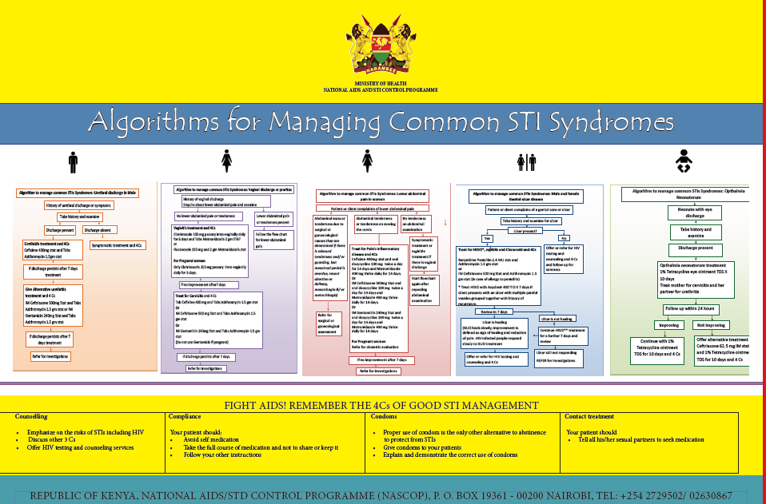

**2.1: HIV/AIDS**

**INTRODUCTION TO IMMUNE DEFICIENCY SYNDROMS;**

Immune deficiency is a state where the body’s immune system is unable to detect pathologies, antigens and disorders that cause disease and thus provide adequate protection to cells and tissues from damage caused by the action of these disease process or pathogens.

**Aetiology of immune deficiency;**

1. **Inherited causes**;

1)    Sickle cell disease- Occur in splenic sequestration and asplenism that follows the condition.

2)   Leukemia;- Results to the destruction of haemopoietic stem cells resulting to pancytopenia (reduction in all cell types) including leucocytes, neutrophils and eosinophils.

1. **Acquired;**

1)    Infections;

Bacterial.

1. Tuberculosis.

Viral.

1. HIV.
2. CMV
3. EBV.
4. Yellow fever.

Cancers.

2)   Noninfectious;

A. Nutritional

1. Protein energy malnutrition.
2. Starvation.

B. Drugs;

1.     Sulphonamides.

2.    Chemotherapy for cancer.

3.    Corticosteroids.

C. Irradiation of the PHSC.

Acquired agents cause acquired immune deficiency syndrome **(AIDS)**while inherited factors cause inherited immune deficiency syndrome **(IIDS).**

The most common infectious agent that cause immune deficiency in our setting is HIV. Cancers are catching up as a significant cause of immune

**HIV/AIDS;**

HIV disease is a chronic infectious disease caused by the Human Immuno Deficiency Virus, which is characterized by spectrum starting from primary infection, with or without the acute syndrome, followed by a relatively long period of asymptomatic stage after which in most patient’s progress to advanced and life threatening disease (AIDS).

**Historical Back Ground**

**1981:**AIDS was first recognized in USA among Homosexual males PCP was seen among 5 homosexuals. Kaposi’s sarcoma was diagnosed in 26 homosexuals.

**1983:**HIV virus was isolated from a patient with lymphadenopathy

**1984:**HIV virus was clearly demonstrated to be the causative agent for AIDS

**Mode of Transmission of HIV;**

**1.    Sexual Transmission:**

Is the major mode of transmission worldwide ( 90 % )

1)    The virus is found in high quantities in the sexual fluids (seminal and vaginal fluid) of people with HIV infection with in infected monocytes and in cell-free state.

2)   Anal sex appears to be the sexual practice carrying the highest risk of transmitting HIV. The reasons being rectal mucosa is thin and fragile and there are susceptible cells ( Langerhans cells ) in the rectal mucosa.

3)   Vaginal sex is also an effective from of transmission.

4)   The presence of other STDs like Syphilis , Gonorrhea etc increase the risk of acquiring or transmitting HIV infection by several fold, as the quantity of the virus in seminal or vaginal fluid significantly increase and the number of infected monocytes is high around the genital area in patients with STDs.

5)   Oral sex may have some risk however there are no reports so far attributable to oral sex.

**2.   Transmission through blood and blood products;**

IV drug abusers who share needles and syringes have high risk .This is the main mode of transmission in Eastern Europe.

Blood or blood products transfusion from infected donors (the risk of infection I s90-100 %). Currently the risk is very minimal as blood and blood products are screened carefully using antibody and p24 antigen testing to identify donors in the widow period.

Transmission through sharp instruments, injection needles etc. There may be a risk of transmission from one patient to another or from an infected patient to health care provider

**3.   Mother to Child Transmission;**

Without any intervention, the risk of mother to child transmission is 30-45% in the developing world and 15-30% in the developed world .

HIV may be transmitted from infected mothers to children during;

                                     i.        Pregnancy:-10 % before the 3rd Trimester

                                    ii.        Labor and Delivery:- 70 % late pregnancy and during labor

                                   iii.        Breast Feeding :- 10-15 %

MTCT is by far the largest source of HIV infection in children under 15.

**FACTORS INFLUENCING MTCT**

**1.    Maternal Factors;**

1. Maternal viral Load: The higher the viral load, the higher is the risk of MTCT
2. Woman becomes infected with HIV during pregnancy
3. Severe immune deficiency
4. Clinical and immunological state
5. Use of ART during pregnancy and postpartum to mother and newborn
6. Viral, bacterial, and parasitic placental infection (especially malaria)
7. Nutritional status, particularly vitamin A

**2.   Labor and Delivery;**

1. Prolonged rupture of membranes (>4 hours)
2. Acute chorioamnionitis
3. Invasive fetal monitoring or delivery techniques
4. Mixing of maternal and fetal body fluids
5. Episiotomy
6. First infant in a multiple birth

**3.   Fetal Conditions;**

1. Premature delivery
2. Immature immune status
3. First-born twin

**4.   Infant Feeding Practices/Breastfeeding;**

1. Mother becomes infected with HIV while breastfeeding (risk increases up to 20%)
2. Mixed feeding (breast milk and other foods) increases risk
3. Breast pathologies (lesions, infections)
4. Advanced disease in the mother
5. Poor maternal nutritional status
6. Breastfeeding during the first 4–6 months
7. The longer mother breastfeeds, the greater the risk

HIV is not spread via non-sexual everyday casual contact between people like kissing, hugging and sharing common utensils, baths etc.

HIV infected people are considered most infectious soon after acquiring the infection and during the AIDS (symptomatic) phase. However, remember that it is possible to transmit HIV any time during the disease.

**2.3: HIV/AIDS (STRUCTURE AND LIFECYCLE OF HIV)**

**The pathogen- HIV;**

HIV is a retrovirus which belongs to the sub family of lente virus. HIV virus is cytopathic virus.

There are 2 main Types of the virus;

**1)   HIV- 1:**

This is the most common cause of HIV Disease throughout the world and it has several groups and subtypes;

                     i.        **M group**which comprises 9 subtypes: A,B,C,D,F,G,H,J,K, as well as growing number of major circulating recombinant forms ( CRFs ) e.g. AE , AG etc

**ii.      G roup O (outliers)**: relatively rare seen in Cameron and Gambia

**iii.      N group: (reported only in Cameroon)**

**Global Pattern of HIV -1 distribution**

1.     **Africa:**> 75 % of strains recovered to date have been subtypes A, C and D with C being the most common

2.    **Europe and Americas**: **s**ubtype B is the predominant strain.

3.    **Asia:**recombinant forms such AE account of the infections in south East Asia while subtype C is prevalent in India. Subtype B is also seen in Asia.

**HIV - 2:**

Was first identified in West Africa and it is mostly confined to West Africa, however a number of cases which can be traced to West Africa are found worldwide.

**Viral Morphology;**

HIV is Spherical shaped virus. The most important parts of the virus are:-

1)    Its viral envelop has many small spikes which consists of two important glycopropteins;

                                     i.        Glycoprotein- gp41 and

                                    ii.        Glycoprotein-gp120

Which play an important role when the virus attaches to its host cells.

2)   The viral capsid ( core ) which contains two single stranded viral RNA and an important enzyme for the virus called reverse transcriptase enzyme.

3)   The reverse transcriptase enzyme plays an important step in the life cycle of the virus. It converts the single stranded viral RNA into double stranded DNA ( this process is called reverse transcription).

**Characteristics of HIV;**

HIV infect cells that express CD4 receptor molecules;

1.     The CD4 receptors are present on various types of blood cells including

                     i.        Lymphocytes,

                    ii.        Macrophages,

                   iii.        Monocytes,

                   iv.        Tissue cells (e.g. Dendirtic cells in the genital tract and ano-rectal region) and

                    v.        Glial cells of brain.

2.    Successful entry of the virus to a target cell also requires cellular co-receptors

                     i.        A fusion co-receptor is designated;

a.    CXCR5 for T-cell tropic stain.

b.    CCR4 for monocyte -macrophage tropic strains.

c.     The receptor and co-receptors of CD4 cells interact with HIV’s gp-120 and gp-41 proteins during entry into a cell.

**Life Cycle of HIV: Replication;**

1.     Attachment /binding and fusion of the virus to the host cells

The receptor and co-receptors of CD4 cells interact with HIV’s gp-120 and gp-41 proteins during entry into a cell.

2.    Uncoatting of the viral capsid and release of Viral RNA into the cytoplasm of the host cell.

3.    Reverse transcription: Viral RNA is concerted in to Double stranded DNA by reverse transcriptase enzyme

4.    Translocation : viral DNA is Imported to cell nucleus

5.    Integration of proviral DNA to host-cell DNA

6.    Cellular activation causes transcription (copying) of HIV DNA back to RNA

                                     i.        Some RNA translated to HIV proteins.

                                    ii.        Other RNA moved to cell membrane

7.    Viral Assembly :HIV assembled under cell membrane and buddes from cell

8.    Maturation : viral Proteases enzymes cleave longer proteins in to important viral proteins and help to convert immature viral particle into and infectious HIV.

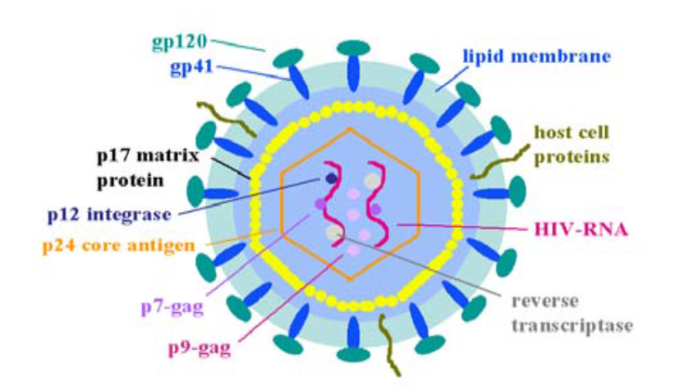

**SUMMARY OF LIFE CYCLE**

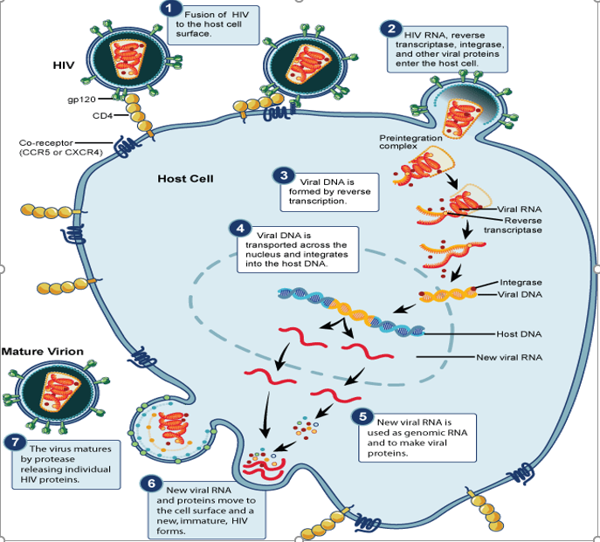

 (Pathogenesis of HIV)

**Pathogenesis of HIV/AIDS;**

CD4 positive T-Lymphocytes (also known as T helper cells) play central role in the defense mechanism of the body against infection. They mainly coordinate the **Cell mediated immune system**and also assist the **antibody mediated immune system**.

1.     HIV virus has special affinity to CD4 T-cells and infects them.

2.    HIV infection is characterized by a profound immunodeficiency from progressive decline of T-helper cells.

3.    The pathogenetic mechanism of HIV disease is multi-factorial and multiphasic and it differs in different stage of the disease.

**Mechanism of CD4 Cell Depletion on HIV infection;**

1.     HIV-mediated direct cytopathicity (single cell killing) – infected CD4 cells die.

2.    HIV-mediated syncytia formation.

3.    Defect in CD4 T-cell regeneration in relation to the rate of destruction.

4.    Maintenance of homeostasis of total T-lymphocytes (decreased CD4, increased CD8)

5.    HIV-specific immune response (killing of virally infected and innocent cells)

6.    Auto-immune mechanism.

7.    Programmed cell death (apoptosis).

Qualitative abnormalities (even the existing CD4 cells are dysfunctional);

1)    Impaired expression of IL-2.

2)   Defective IL-2 and INF-Alfa production.

3)   Decreased help to B-cells in production of immunogloblins.

**Peculiar Characteristics of HIV and reasons for Persistent Viremia;**

HIV is a unique infection in that, though the body reacts by producing antibodies to destroy the virus, the virus is not cleared, except partially in the early period of infection.

A chronic infection is established, and it persists with varying degrees of viral replication. Viral replication is continuous in all stages (early infection, during the long period of clinical latency, and in advanced stage.) There is no virological latency.

Despite robust immune reaction, HIV evades elimination by the immune system and a chronic infection is established. Some of the mechanisms are:

                     i.        High level of viral mutation – HIV has an extraordinary ability to mutate

                    ii.        Large pool of latently infected cells that cannot be eliminated by viral-specific CTLs

                   iii.        Virus homes in lymphoid organs, while antibody is in the circulation

                   iv.        Exhaustion of CD8 T-lymphocytes by excessive antigen stimulation

                    v.        HIV attacks CD-4 T-cells, which are central to both humeral and-cell mediated immunity.

                   vi.        HIV seeds itself in areas of the body where sufficient antibodies might not reach, e.g., the central nervous system.

**Progression of HIV is different in different individuals;**

**1.    Rapid progressors:**

After the initial infection patients progress fast and develop OIs and die within 2-3 years. Account for 15 % of all patients.

**2.   Normal Progressors:**

After the initial primary infection patients remain health for 6- 8 years before they start having overt clinical manifestations: account for 80 % of all patients.

**3.   Long term survivors:**

Patients who remain alive for 10-15 years after initial infection. In most the diseases might have progressed and there may be evidences of immunodeficiency.

**4.   Long term non progressors:**

This is individuals who have been infected with HIV for > 10 years. Their CD4 count may be in the normal range and they may remain clinically stable for several years

**Factors affecting disease progression in HIV Infected individuals;**

**1)   Viral set point:**The level of steady-state viremia (set-point) at six months to one year after infection, has an important prognostic implication for progression of HIV disease. Those with a high viral set-point have faster progression to AIDS, if not treated

**2)   Immune response**

                                     i.        High CD8 slow progression

                                    ii.        Low CD8 rapid decline

**3)   Viral type**; HIV 2 slow course

**4)   Concomitant conditions**

                     i.        Malnutrition hastens the progression of HIV

                    ii.        Chronic infectious conditions e.g. Tuberculosis

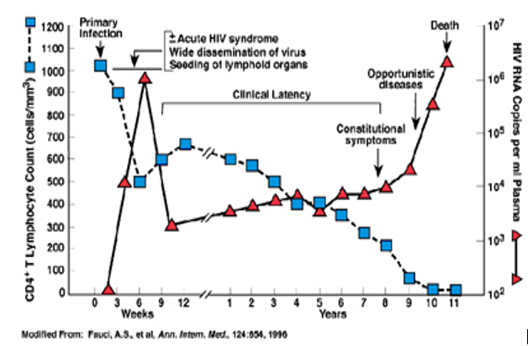

**DIAGNOSIS AND LABORATORY MONITORING OF HIV**

**Pathogenesis of HIV/AIDS;**

CD4 positive T-Lymphocytes (also known as T helper cells) play central role in the defense mechanism of the body against infection. They mainly coordinate the **Cell mediated immune system**and also assist the **antibody mediated immune system**.

1.     HIV virus has special affinity to CD4 T-cells and infects them.

2.    HIV infection is characterized by a profound immunodeficiency from progressive decline of T-helper cells.

3.    The pathogenetic mechanism of HIV disease is multi-factorial and multiphasic and it differs in different stage of the disease.

**Mechanism of CD4 Cell Depletion on HIV infection;**

1.     HIV-mediated direct cytopathicity (single cell killing) – infected CD4 cells die.

2.    HIV-mediated syncytia formation.

3.    Defect in CD4 T-cell regeneration in relation to the rate of destruction.

4.    Maintenance of homeostasis of total T-lymphocytes (decreased CD4, increased CD8)

5.    HIV-specific immune response (killing of virally infected and innocent cells)

6.    Auto-immune mechanism.

7.    Programmed cell death (apoptosis).

Qualitative abnormalities (even the existing CD4 cells are dysfunctional);

1)    Impaired expression of IL-2.

2)   Defective IL-2 and INF-Alfa production.

3)   Decreased help to B-cells in production of immunogloblins.

**Peculiar Characteristics of HIV and reasons for Persistent Viremia;**

HIV is a unique infection in that, though the body reacts by producing antibodies to destroy the virus, the virus is not cleared, except partially in the early period of infection.

A chronic infection is established, and it persists with varying degrees of viral replication. Viral replication is continuous in all stages (early infection, during the long period of clinical latency, and in advanced stage.) There is no virological latency.

Despite robust immune reaction, HIV evades elimination by the immune system and a chronic infection is established. Some of the mechanisms are:

1. High level of viral mutation – HIV has an extraordinary ability to mutate
2. Large pool of latently infected cells that cannot be eliminated by viral-specific CTLs
3. Virus homes in lymphoid organs, while antibody is in the circulation
4. Exhaustion of CD8 T-lymphocytes by excessive antigen stimulation
5. HIV attacks CD-4 T-cells, which are central to both humeral and-cell mediated immunity.
6. HIV seeds itself in areas of the body where sufficient antibodies might not reach, e.g., the central nervous system.

**Progression of HIV is different in different individuals;**

**1.    Rapid progressors:**

After the initial infection patients progress fast and develop OIs and die within 2-3 years. Account for 15 % of all patients.

**2.   Normal Progressors:**

After the initial primary infection patients remain health for 6- 8 years before they start having overt clinical manifestations: account for 80 % of all patients.

**3.   Long term survivors:**

Patients who remain alive for 10-15 years after initial infection. In most the diseases might have progressed and there may be evidences of immunodeficiency.

**4.   Long term non progressors:**

This is individuals who have been infected with HIV for > 10 years. Their CD4 count may be in the normal range and they may remain clinically stable for several years

**Factors affecting disease progression in HIV Infected individuals;**

**1)   Viral set point:**The level of steady-state viremia (set-point) at six months to one year after infection, has an important prognostic implication for progression of HIV disease. Those with a high viral set-point have faster progression to AIDS, if not treated

**2)   Immune response**

                                     i.        High CD8 slow progression

                                    ii.        Low CD8 rapid decline

**3)   Viral type**; HIV 2 slow course

**4)   Concomitant conditions**

                     i.        Malnutrition hastens the progression of HIV

                    ii.        Chronic infectious conditions e.g. Tuberculosis

**Serologic Tests:**

**1.    HIV antibody tests :-**

Detect antibodies formed by the immune system against HIV

**1)   ELISA : used to be standard screening test for HIV**

·         Tests for a number of antibody proteins in combination

·         A very *sensitive*test ( . 99.5 % ), but not very *specific*

·         A positive result needs to be confirmed by Western blot for confirmation

·         The test need skilled personnel , takes several hours.

**2)   Western blot: is an excellent confirmatory test.**

·         It has high specificity but relatively poor sensitivity

·         It should not be used for screening purpose

**3)   Rapid HIV antibody testes**

**Advantages of HIV Rapid tests:**

1. Rapid tests have reasonably good sensitivity and specificity ( >99 % ).
2. Easy logistically , does not need continuous water or electric supply.
3. Can be done by less skilled personnel and the interpretation of results is easy.
4. Test result can be made available in < 30 minutes.

**4)   HIV antigen assays ( Tests )**

**1)   P24 antigen capture assay:**

This test detects p24 viral protein in the blood of HIV infected individuals. This viral protein can be detected during early infection, before seroconversion. Thus this test is used to detect blood donors during the Window period.

**2.   DNA – PCR : Viral replication**

This is an extremely sensitive test -can detect 1-10 copies of HIV proviral DNA per ml of blood.

It uses PCR technology to amplify proviral DNA

This test is costly and needs sophisticated instruments and highly skilled professional

It is highly sensitive and the chance of false positivity is high. hence it should not be used for making initial diagnosis of HIV infection.

**Uses of DNA PCR;**

                             i.        To make early diagnosis of HIV in HIV exposed infants as serology tests are unable to diagnose HIV till the infant is 18 months old

                            ii.        To diagnose or confirm virologic failure in patients who are not responding to ART

                           iii.        When there is indeterminate serology

                           iv.        For quality control of HIV rapid test.

**3.   CD4 T cell count :**

CD4 cells play a crucial role in the body defense mechanism, measuring the amount of CD4 cells is an important indicator of the level of immune suppression that a patient infected with HIV has;

                     i.        The average CD4 count of a normal person is in the range of 1000-1200/mm3.

                    ii.        In patients with HIV CD4 count drops by an average of 50 - 100 cells per year

                   iii.        Tells you the level of immune damage inflicted by HIV.

                   iv.        It should never used to make diagnosis of HIV

                    v.        CD4 count may be variable depending on circumstances

a.    Diurnal variation; High evening low at midnight

b.    Inter current infection, use of steroids and stress could affect CD4 count

                   vi.        Following the trend in CD4 count is us full in clinical decision making.

                 vii.        Percentage of CD4 count is useful in children below 6 years

                viii.        Importance’s of CD4 count

a.    To decide eligibility of a patient for ART

b.    To follow the progress of a patient on ART

c.     To diagnose immunologic failure in patients who are not responding well to ART

**Additional tests in HIV infection include:**

1.     HBV , HCV

2.    FBP and ESR

3.    AST and ALT

4.    Serum Creatinine

5.    Syphilis serology: RPR

6.    AFB chest X-Ray where possible

7.    Stool examination for parasites

8.    Malaria blood slide

9.    Pregnancy test for women in child bearing age

**CDC AND WHO CLASSIFICATION OF HIV**

**CDC CLASSIFICATION SYSTEM FOR HIV INFECTION**

The CDC categorization of HIV/AIDS is based on the lowest documented CD4 cell count and on previously diagnosed HIV-related conditions. For example, if a patient had a condition that once met the criteria for category B but now is asymptomatic, the patient would remain in category B. Additionally, categorization is based on specific conditions, as indicated below. Patients in categories A3, B3, and C1-C3 are considered to have AIDS.

CDC Classification System for HIV-Infected Adults and Adolescents

| CD4 Cell Categories | Clinical Categories | | |
| --- | --- | --- | --- |
| Abbreviations: PGL = persistent generalized lymphadenopathy | | | |
|  | A Asymptomatic, Acute HIV, or PGL | B* Symptomatic Conditions, not A or C | C# AIDS-Indicator Conditions |
| (1) ≥500 cells/µL | A1 | B1 | C1 |
| (2) 200-499 cells/µL | A2 | B2 | C2 |
| (3) <200 cells/µL | A3 | B3 | C3 |

*\*****Category B Symptomatic Conditions***

Category B symptomatic conditions are defined as symptomatic conditions occurring in an HIV-infected adolescent or adult that meet at least one of the following criteria:

* They are attributed to HIV infection or indicate a defect in cell-mediated immunity.
* They are considered to have a clinical course or management that is complicated by HIV infection.

Examples include, but are not limited to, the following:

1. Bacillary angiomatosis
2. Oropharyngeal candidiasis (thrush)
3. Vulvovaginal candidiasis, persistent or resistant
4. Pelvic inflammatory disease (PID)
5. Cervical dysplasia (moderate or severe)/cervical carcinoma in situ
6. Hairy leukoplakia, oral
7. Herpes zoster (shingles), involving two or more episodes or at least one dermatome
8. Idiopathic thrombocytopenic purpura
9. Constitutional symptoms, such as fever (>38.5ºC) or diarrhea lasting >1 month
10. Peripheral neuropathy

*#****Category C AIDS-Indicator Conditions***

1. Bacterial pneumonia, recurrent (two or more episodes in 12 months)
2. Candidiasis of the bronchi, trachea, or lungs
3. Candidiasis, esophageal
4. Cervical carcinoma, invasive, confirmed by biopsy
5. Coccidioidomycosis, disseminated or extrapulmonary
6. Cryptococcosis, extrapulmonary
7. Cryptosporidiosis, chronic intestinal (>1 month in duration)
8. Cytomegalovirus disease (other than liver, spleen, or nodes)
9. Encephalopathy, HIV-related
10. Herpes simplex: chronic ulcers (>1 month in duration), or bronchitis, pneumonitis, or esophagitis
11. Histoplasmosis, disseminated or extrapulmonary
12. Isosporiasis, chronic intestinal (>1-month duration)
13. Kaposi sarcoma
14. Lymphoma, Burkitt, immunoblastic, or primary central nervous system
15. *Mycobacterium avium* complex (MAC) or *Mycobacterium kansasii*, disseminated or extrapulmonary
16. *Mycobacterium tuberculosis*, pulmonary or extrapulmonary
17. *Mycobacterium*, other species or unidentified species, disseminated or extrapulmonary
18. *Pneumocystis jiroveci* (formerly *carinii*) pneumonia (PCP)
19. Progressive multifocal leukoencephalopathy (PML)
20. *Salmonella* septicemia, recurrent (nontyphoid)
21. Toxoplasmosis of brain
22. Wasting syndrome caused by HIV (involuntary weight loss >10% of baseline body weight) associated with either chronic diarrhea (two or more loose stools per day for ≥1 month) or chronic weakness and documented fever for ≥1 month

**WHO Clinical Staging of HIV/AIDS and Case Definition**

The clinical staging and case definition of HIV for resource-constrained settings were developed by the WHO in 1990 and revised in 2007. Staging is based on clinical findings that guide the diagnosis, evaluation, and management of HIV/AIDS, and it does not require a CD4 cell count. This staging system is used in many countries to determine eligibility for antiretroviral therapy, particularly in settings in which CD4 testing is not available. Clinical stages are categorized as 1 through 4, progressing from primary HIV infection to advanced HIV/AIDS. These stages are defined by specific clinical conditions or symptoms. For the purpose of the WHO staging system, adolescents and adults are defined as individuals aged ≥15 years.

**WHO CLINICAL STAGING OF HIV/AIDS FOR ADULTS AND ADOLESCENTS**

|  |
| --- |
| **Primary HIV Infection** |
| 1. Asymptomatic 2. Acute retroviral syndrome |
| **Clinical Stage 1** |
| 1. Asymptomatic 2. Persistent generalized lymphadenopathy |
| **Clinical Stage 2** |
| 1. Moderate unexplained weight loss (<10% of presumed or measured body weight) 2. Recurrent respiratory infections (sinusitis, tonsillitis, otitis media, and pharyngitis) 3. Herpes zoster 4. Angular cheilitis 5. Recurrent oral ulceration 6. Papular pruritic eruptions 7. Seborrheic dermatitis 8. Fungal nail infections |
| **Clinical Stage 3** |
| 1. Unexplained severe weight loss (>10% of presumed or measured body weight) 2. Unexplained chronic diarrhea for >1 month 3. Unexplained persistent fever for >1 month (>37.6ºC, intermittent or constant) 4. Persistent oral candidiasis (thrush) 5. Oral hairy leukoplakia 6. Pulmonary tuberculosis (current) 7. Severe presumed bacterial infections (e.g., pneumonia, empyema, pyomyositis, bone or joint infection, meningitis, bacteremia) 8. Acute necrotizing ulcerative stomatitis, gingivitis, or periodontitis 9. Unexplained anemia (hemoglobin <8 g/dL) 10. Neutropenia (neutrophils <500 cells/µL) 11. Chronic thrombocytopenia (platelets <50,000 cells/µL) |
| **Clinical Stage 4** |
| 1. HIV wasting syndrome, as defined by the CDC. 2. *Pneumocystis* pneumonia 3. Recurrent severe bacterial pneumonia 4. Chronic herpes simplex infection (orolabial, genital, or anorectal site for >1 month or visceral herpes at any site) 5. Esophageal candidiasis (or candidiasis of trachea, bronchi, or lungs) 6. Extrapulmonary tuberculosis 7. Kaposi sarcoma 8. Cytomegalovirus infection (retinitis or infection of other organs) 9. Central nervous system toxoplasmosis 10. HIV encephalopathy 11. Cryptococcosis, extrapulmonary (including meningitis) 12. Disseminated nontuberculosis mycobacteria infection 13. Progressive multifocal leukoencephalopathy 14. Candida of the trachea, bronchi, or lungs 15. Chronic cryptosporidiosis (with diarrhea) 16. Chronic isosporiasis 17. Disseminated mycosis (e.g., histoplasmosis, coccidioidomycosis, penicilliosis) 18. Recurrent nontyphoidal *Salmonella* bacteremia 19. Lymphoma (cerebral or B-cell non-Hodgkin) 20. Invasive cervical carcinoma 21. Atypical disseminated leishmaniasis 22. Symptomatic HIV-associated nephropathy 23. Symptomatic HIV-associated cardiomyopathy 24. Reactivation of American trypanosomiasis (meningoencephalitis or myocarditis) |

**TREATMENT AND PREVENTION OF HIV**

**Classes of HIV/AIDS Antiretroviral Drugs;**

The antiretroviral medications used to treat HIV/AIDS currently are organized into five major drug classes.

Reverse Transcriptase (RT) Inhibitors interfere with the critical step during the HIV life cycle known as reverse transcription. During this step, the HIV enzyme RT converts HIV RNA to HIV DNA. There are two main types of RT inhibitors.

1)    Nucleoside/nucleotide RT inhibitors are faulty DNA building blocks. When these faulty pieces are incorporated into the HIV DNA (during the process when HIV RNA is converted to HIV DNA), the DNA chain cannot be completed, thereby blocking HIV from replicating in a cell.

2)   Non-nucleoside RT inhibitors bind to RT, interfering with its ability to convert the HIV RNA into HIV DNA.

3)   Protease Inhibitors interfere with the protease enzyme that HIV uses to produce infectious viral particles.

4)   Fusion/Entry Inhibitors interfere with the virus' ability to fuse with the cellular membrane, thereby blocking entry into the host cell.

5)   Integrase Inhibitors block integrase, the enzyme HIV uses to integrate genetic material of the virus into its target host cell.

Multidrug Combination Products combine drugs from more than one class into a single product. To combat virus strains from becoming resistant to specific antiretroviral drugs, healthcare providers recommend that people infected with HIV take a combination of antiretroviral drugs known as highly active antiretroviral therapy (HAART). Developed by NIAID-supported researchers, the HAART strategy combines drugs from at least two different antiretroviral drug classes.

In Development

Another HIV/AIDS drug class known as maturation inhibitors is still in development. If successful, they could potentially prevent HIV from properly assembling and maturing. For example, these treatments could block HIV from forming a protective outer coat or from emerging from human cells.

**Prevention of HIV**

Currently, there is no vaccine to prevent HIV infection nor is there a cure for HIV/AIDS. To reduce your risk of becoming infected with HIV or transmitting the virus to others

1. Get tested regularly for HIV
2. Practice abstinence
3. Remain faithful to your spouse or partner
4. Consistently use male latex or female polyurethane condoms
5. Do not share needles

**Review Questions/Unit Activity**

1. Discuss the management of a 28 year old sexually active female with GUD (Genital Ulcer Disease).
2. Describe the WHO staging of HIV infection